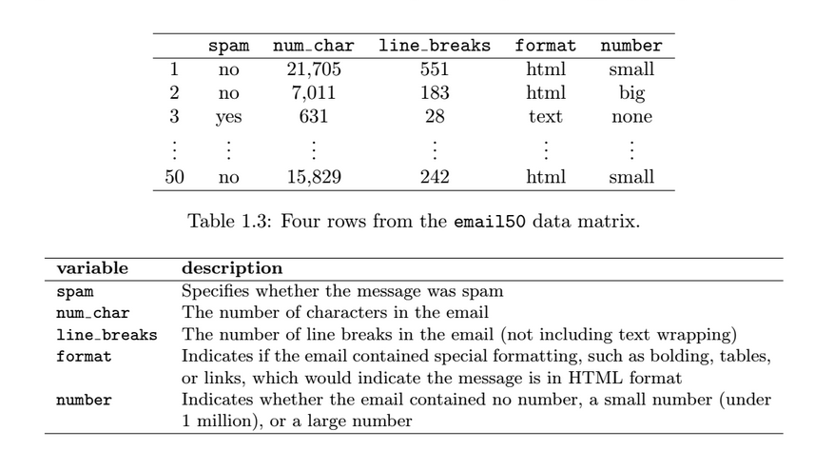Example 1: (Data Basics) Table 1.3 displays rows 1, 2, 3, and 50 of a data set concerning 50 emails received during early 2012. (dataset: email50) (OpenInto Statistics, pg 10 , 3-rd edition)

1. How many cases are there?
2. How many variables are there?
3. Identify quantitative and categorical variables

Example 2 : A random sample of 1000 community college students was asked the following question: “On average, how much time per day do you spend on social media of any kind?”

a) What is the sample?

b) What is the population?

c) What is the sample statistic?

d) What is the population parameter?

Example 3. Identify the type of sampling as census, simple random sample, stratified, cluster, multi-stage, or systematic.

a) Use the company e-mail directory to contact 150 employees from among those employed for less than five years, 150 from among those employed 5 – 10 years, and 150 from among those employed for more than 10 years.

b) Use the company e-mail directory to contact every 50th employee on the list.

c) Select several divisions of the company at random. Within each division, draw a simple random sample of employees to contact.

d) Select several divisions of the company at random and then contact every member of the division.

e) Randomly select 450 employees from the company e-mail directory.

f) Require every employee to be contacted.

**Bias**

* The bias in which some portion of the population is not sampled at all or has a smaller representation in the sample than it has in the population.

__________________.

* The bias introduced by inviting free responses from a large group of people and which tends to favor those with strong opinions: __________________.
* The bias introduced when people cannot or will not respond to a survey: __________________.
* The bias introduced by wording in the survey design that influences the responses: __________________.